AI Software Development Internship
Week 5: Detailed Task Sheet
ZAINAB AKRAM

AI Software Development Internship
Week 5 — Detailed Task Sheet
PART A — EMBEDDINGS FUNDAMENTALS
Practice:
- Run the script above and confirm the "similar meaning" score is noticeably higher than the "unrelated meaning" score.
- Print len(v1) and confirm the embedding is a long list of plain numbers the meaning only shows up when comparing vectors.
- Try two sentences that share many of the same words but mean opposite things and see how close or far apart they land — write down what you observe.
Code:
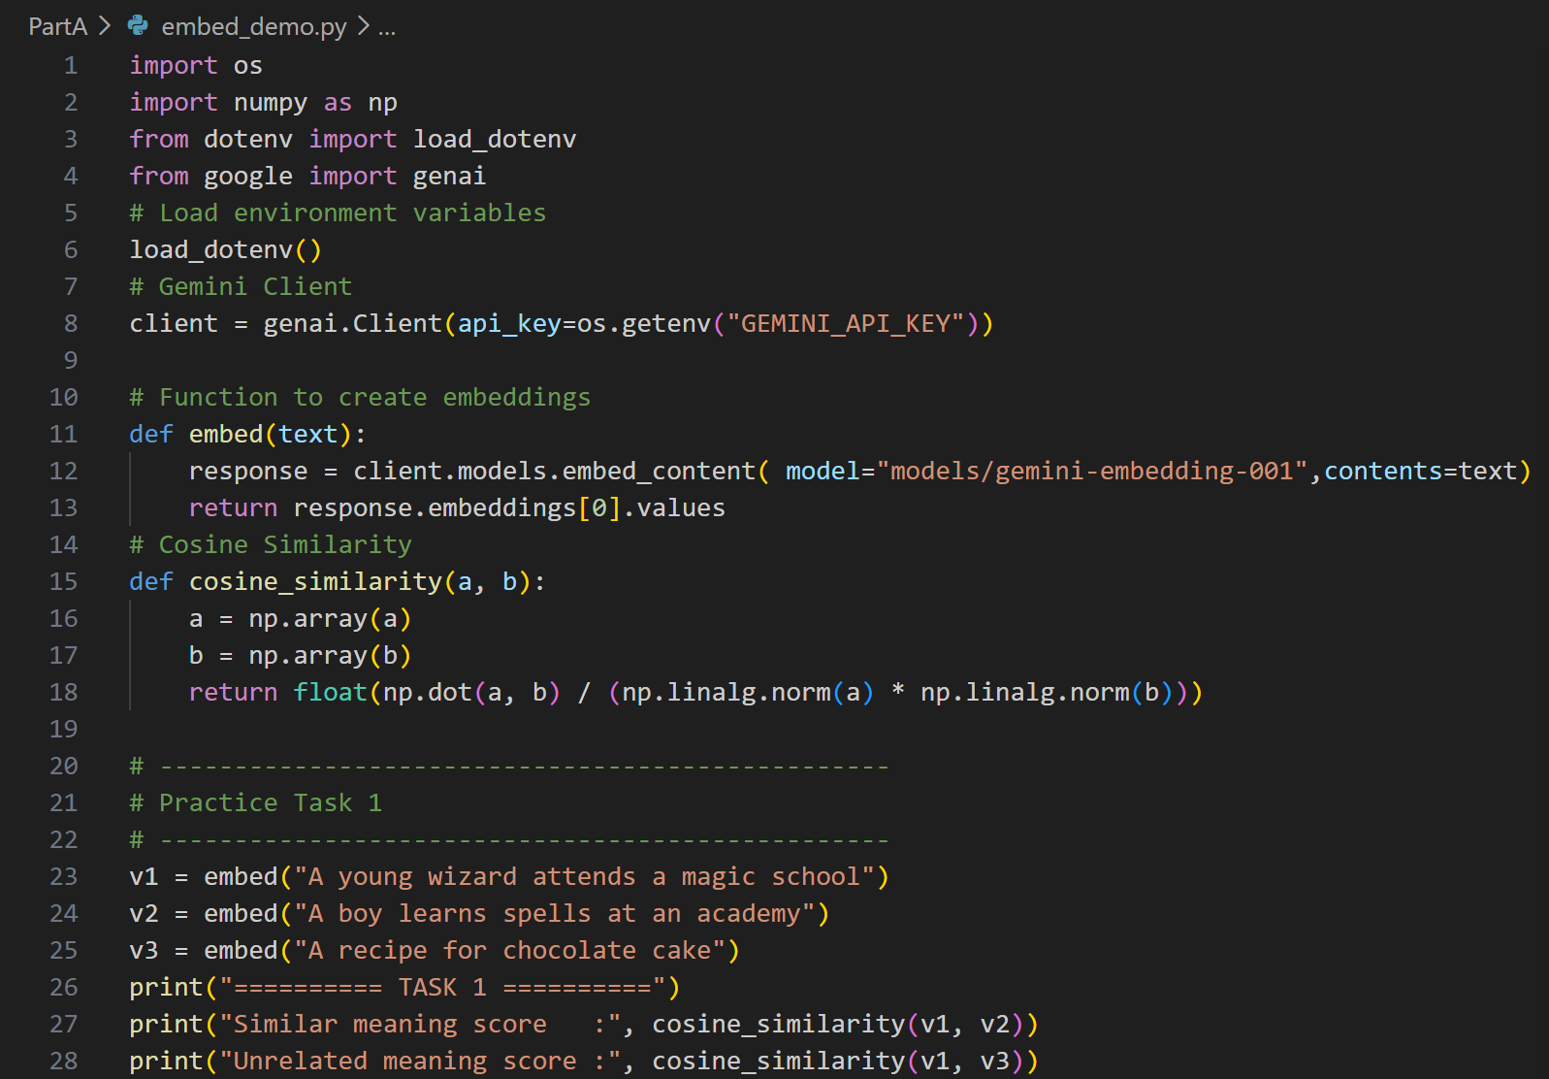
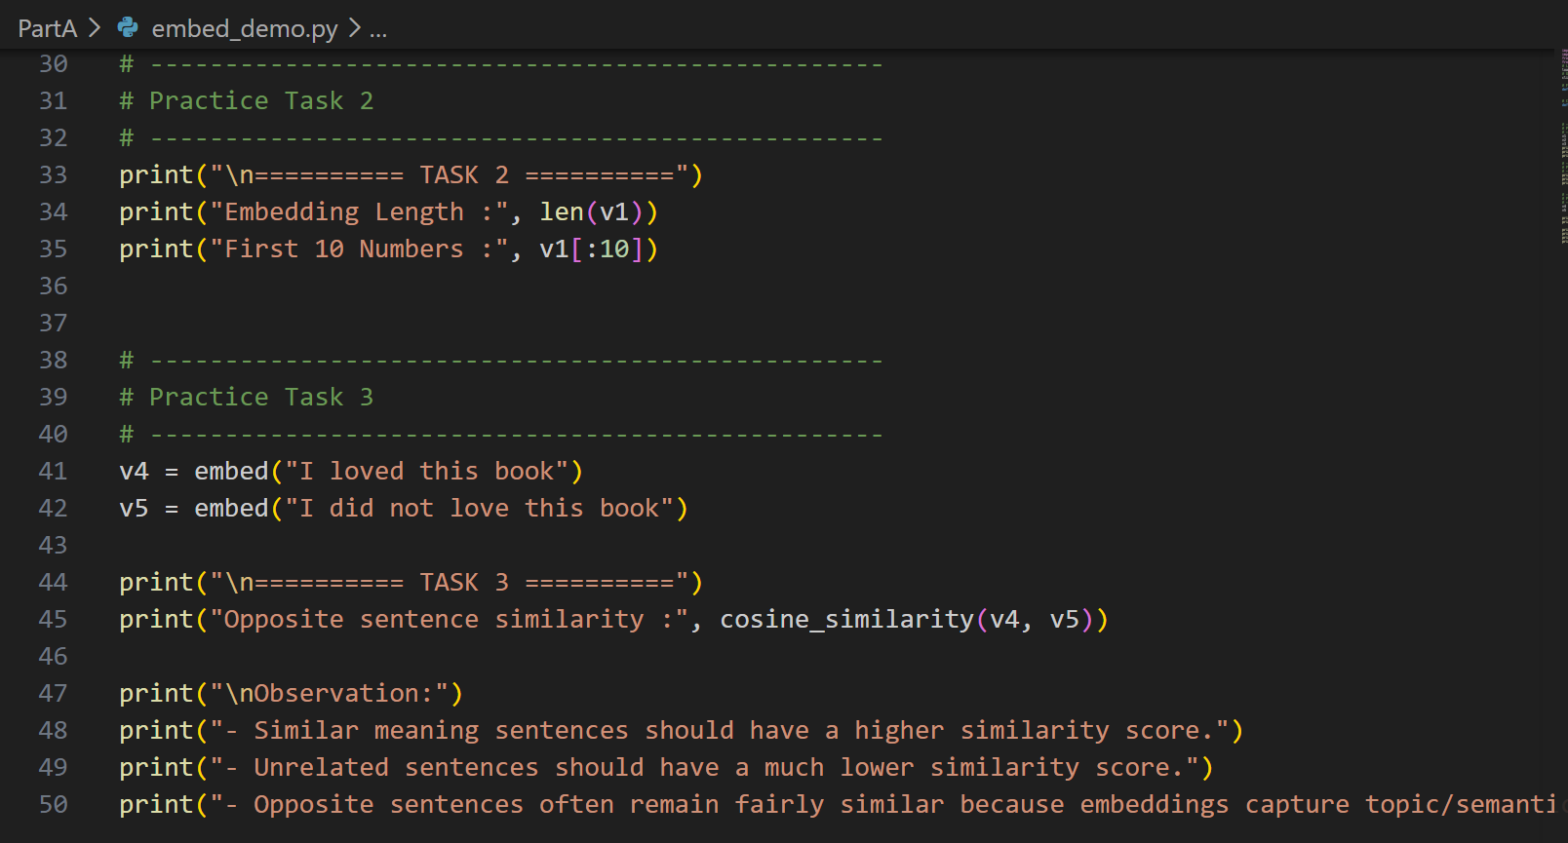
Output:
Task 1: Compare similar vs unrelated sentences
The semantically similar sentences produced a higher cosine similarity score (0.823) than the unrelated sentences (0.536), showing that embeddings capture semantic meaning.
Task 2: Print embedding length
The embedding consists of 3072 floating-point values. Individually the numbers have no readable meaning; only when compared with another embedding can semantic similarity be measured.
Task 3: Opposite meaning sentences
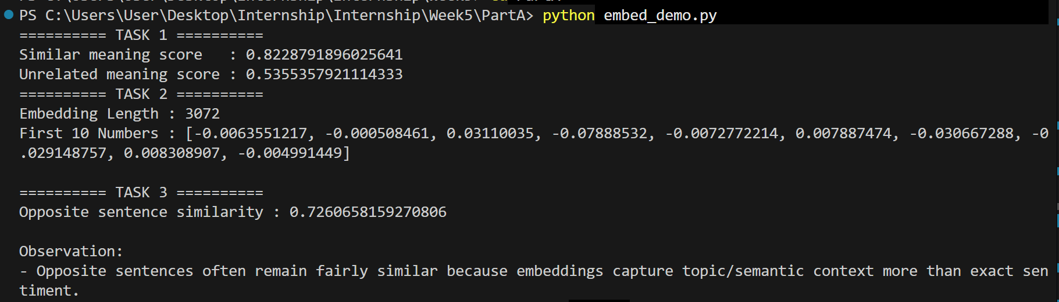

PART B — VECTOR DATABASES
Practice:
- Run the script above and confirm the space-related query returns the science fiction book first.
- Add a metadata filter to the query (where={"category": "Fantasy"}) and confirm it only searches within that category.
- Add two more documents of your own and re-run a few queries to get comfortable with the add/query pattern.
Code:
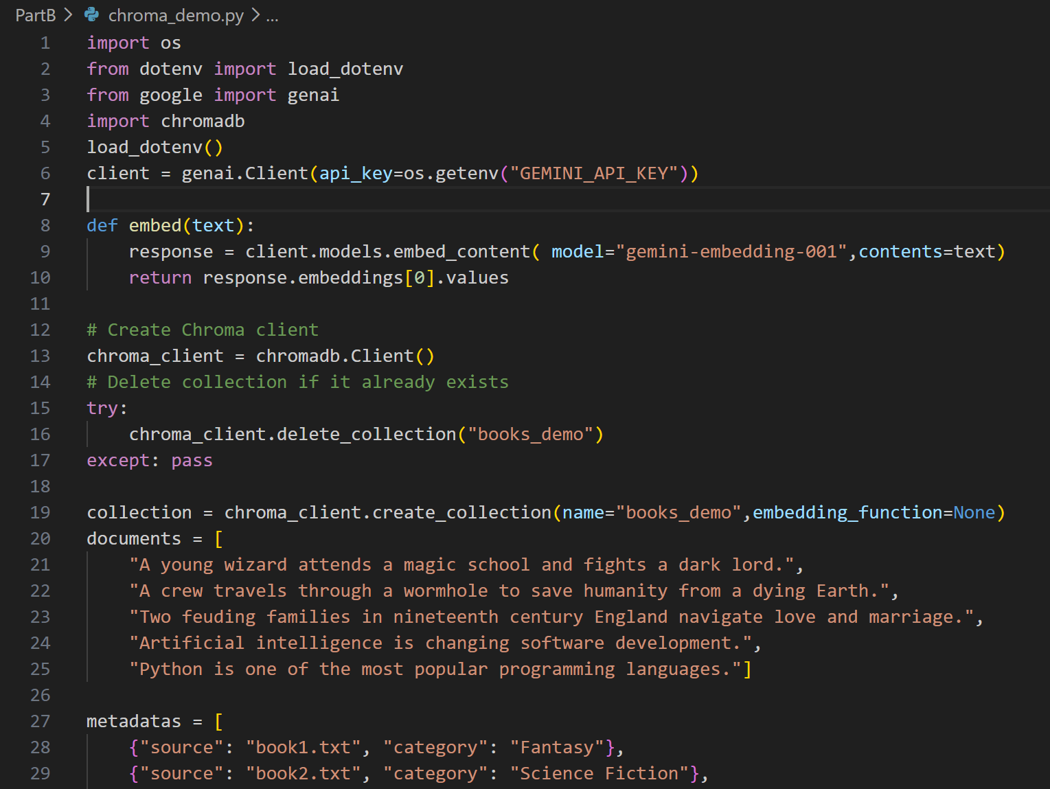
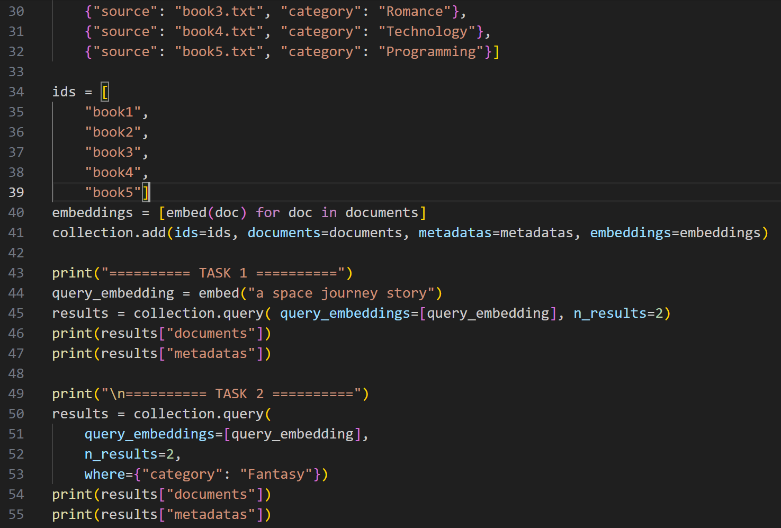
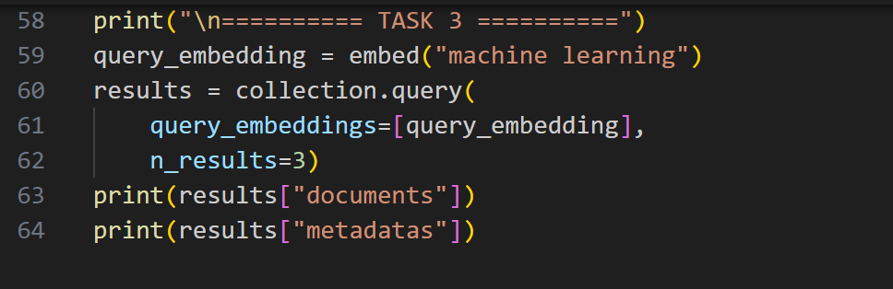
Output:
Task 1: Semantic Vector Search
Task 2: Metadata Filtering
Task 3: Add Two More Documents
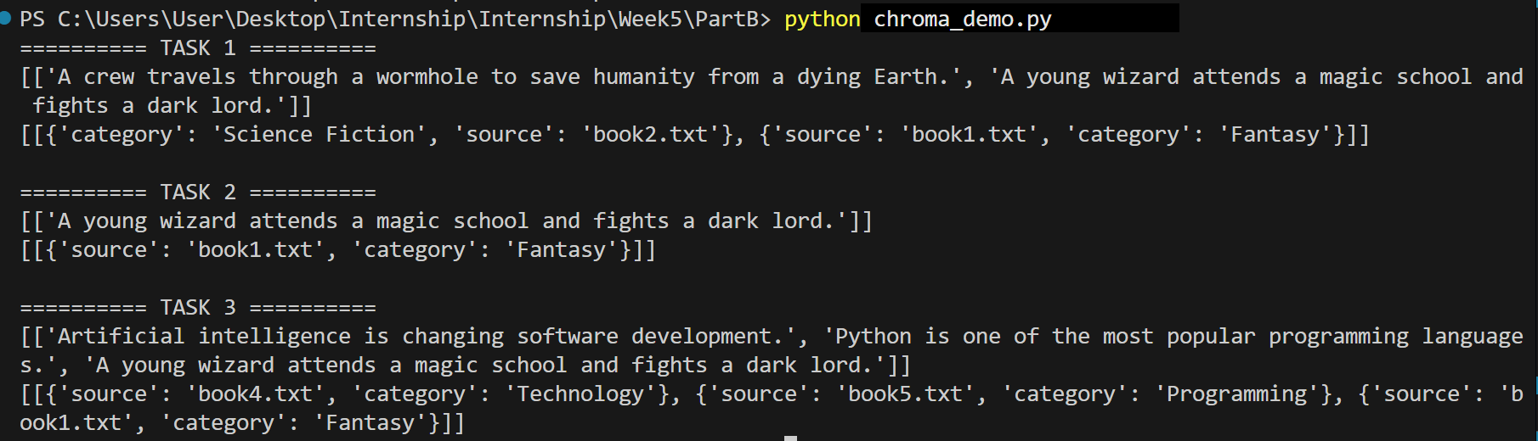
PART C — RAG FUNDAMENTALS: BUILDING THE PIPELINE BY HAND
Practice:
- Add 3–4 short text documents (a couple of paragraphs each, any topic you like) using add_document().
- Ask a question clearly answerable from one of the documents and confirm the retrieved chunks and the final answer both make sense.
- Ask a question that has nothing to do with any of your documents and confirm the model says it doesn't know, instead of making something up.
- Print the source metadata for each retrieved chunk alongside the answer — this is your source attribution.
Code:
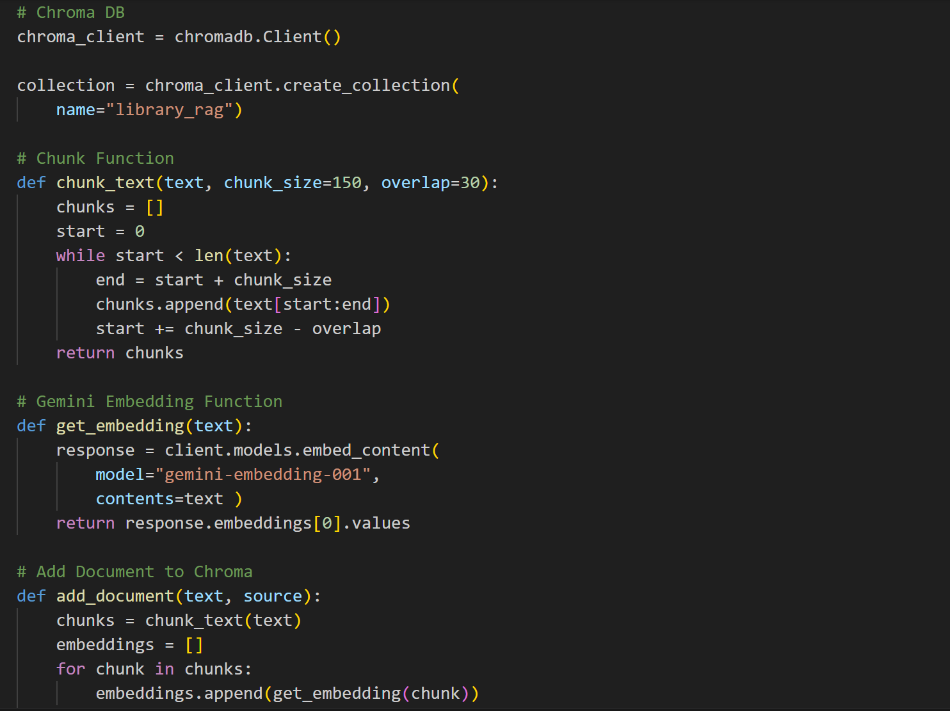
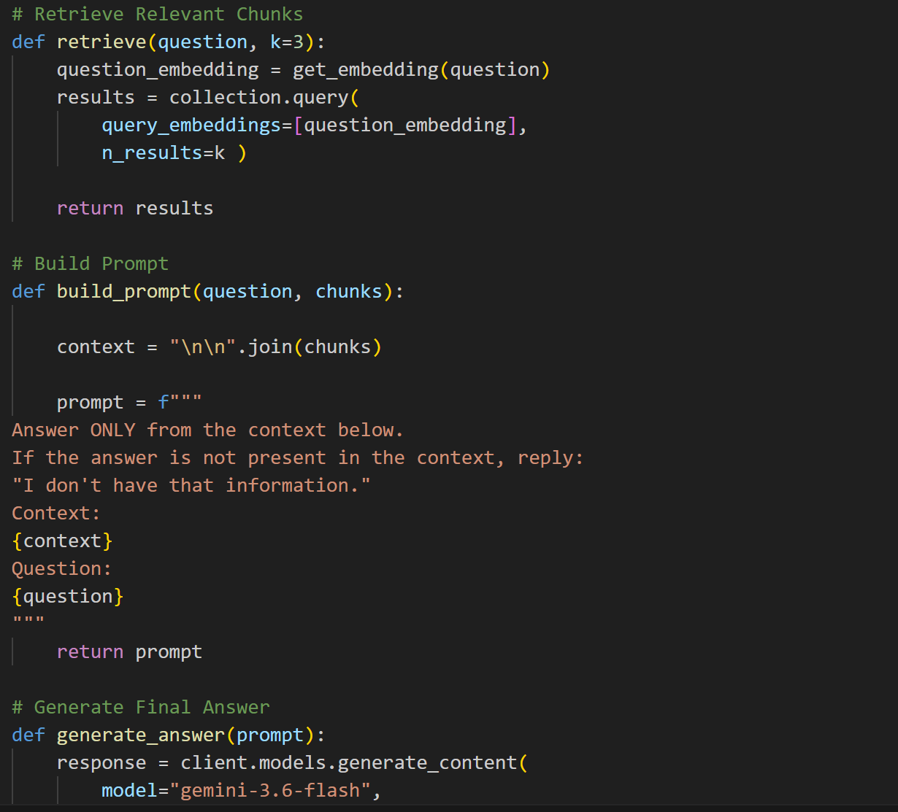
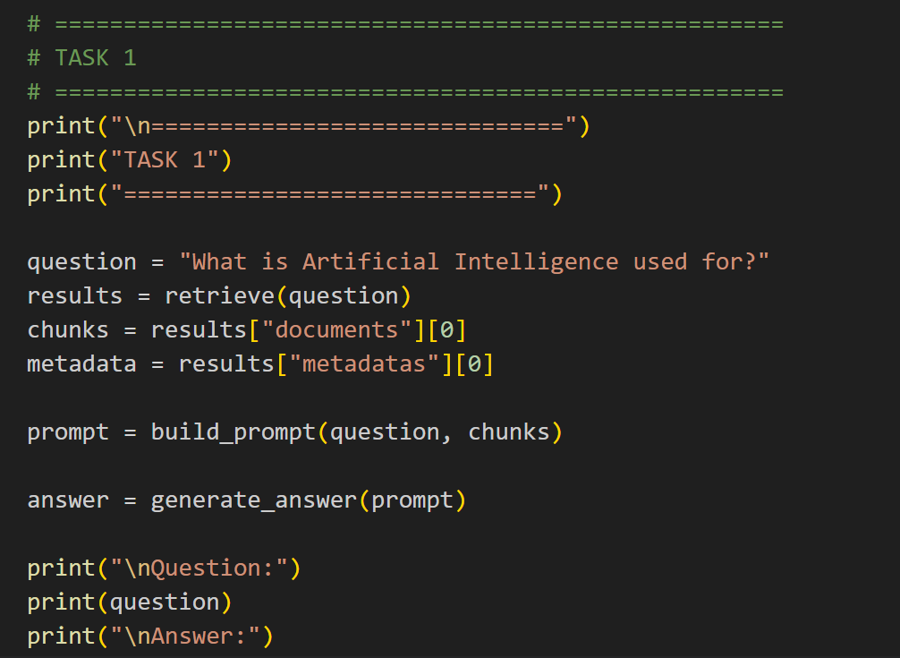
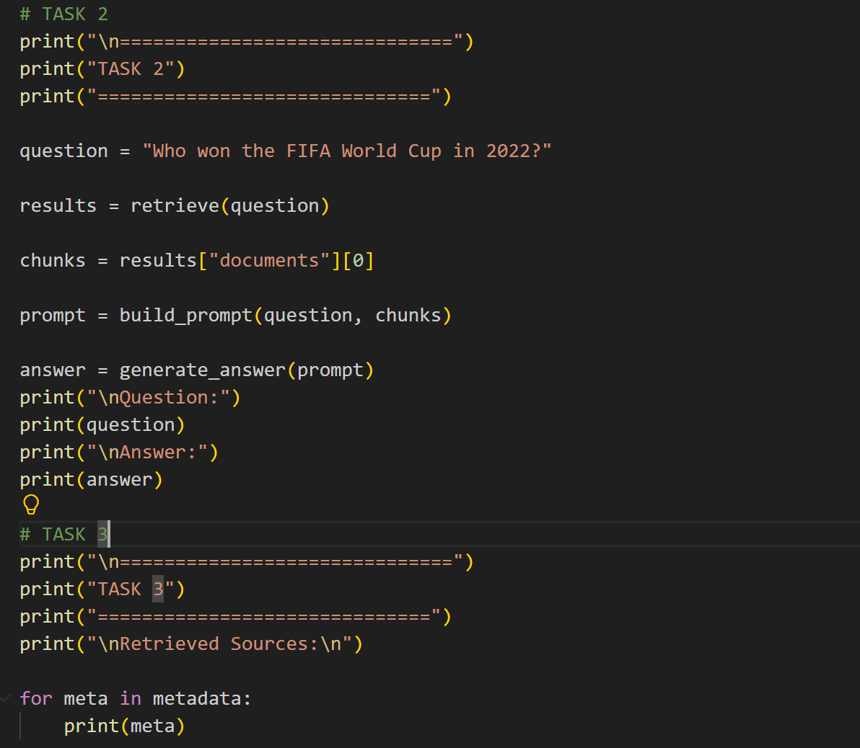
Output:
Task 1
It Loads all 4 documents and asks a question that exists in the documents. Retrieves relevant chunks and generates an answer.
Task 2
Asks a question not covered by the documents. The prompt instructs the model to reply. I don't have that information.
Task 3
Prints the metadata (source and chunk) for the retrieved chunks, satisfying the source attribution requirement.
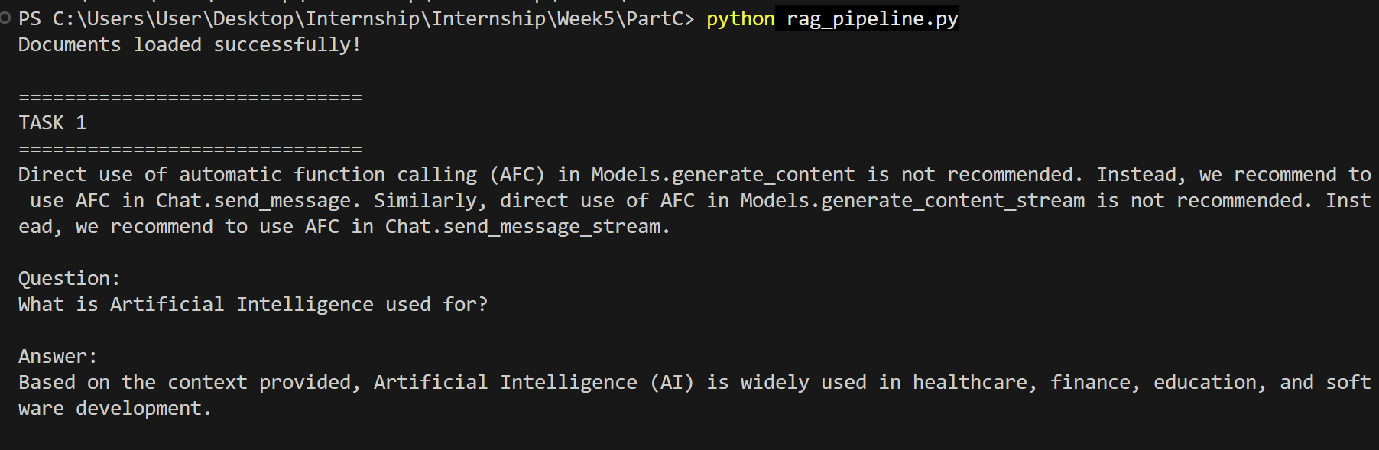
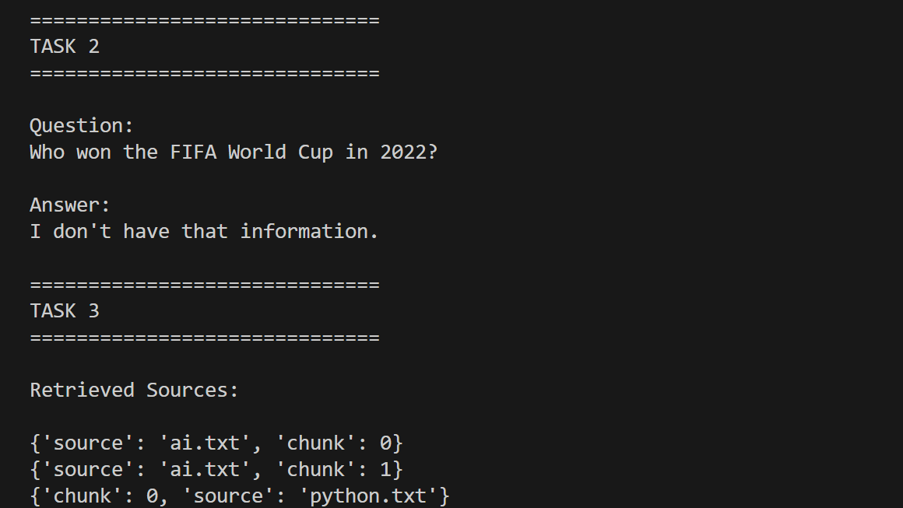
PART D — RAG QUALITY & HALLUCINATION REDUCTION
Practice
- Build a small table of 5 test questions with their expected answers, based on your Part C documents.
- Run each question through your pipeline and mark, for each one: retrieval correct? (yes/no), answer correct? (yes/no).
- For any question that failed, decide whether it was a retrieval failure or a generation failure, and write one sentence explaining why.
- Try halving your chunk size and re-run the same 5 questions — note whether results improved, got worse, or stayed the same.
Code:

Output:

